February 19, 2022

*Via E-mail:* <<OPPOSING_COUNSEL_NAME>>

<<OPPOSING_COUNSEL_EMAIL>>

***RE:*** *<<PROVIDER_SUITNAME>> a/a/o <<INJUREDPARTY_NAME>> v. <<INSURANCECOMPANY_SUITNAME>>, Case No.* <<INDEXORAAA_NUMBER>>

Dear Counselor,

Yesterday I sent you a request for deposition in error in the above-captioned case. Please disregard the request as I sent it in error.

Sincerely,

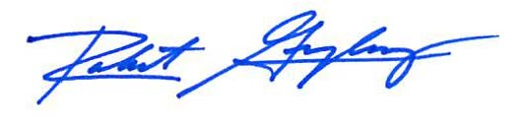

Robert F. Gonzalez, Esq.